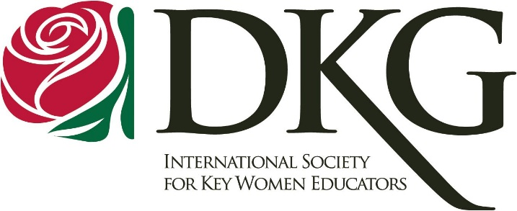

March 2, 2023

My name is Lisa Hall, and I’m a Charlotte based member of Delta Kappa Gamma – Kappa Chapter. Established in 1929, Delta Kappa Gamma is an international honorary society for women educators. We provide members with valuable professional and personal growth, while also seeking to give back to educators and students in our local Charlotte area.

I’m reaching out in hopes that Nothing Bundt Cakes would be willing to make a gift card donation to support our upcoming online auction fundraising event. The goal of this auction is to raise funds to support charities and projects that will benefit educational achievement. In the past, our Kappa Chapter has supported early childhood literacy development through Bright Blessings, literacy materials for summer readers, healthy snacks and hygiene items for homeless children, and also funded various scholarships. We have made financial donations to teachers impacted by hurricanes, and have also helped fund the restoration of an NC public school library collection devastated by hurricane flood waters. Proceeds from this auction will be used for similar purposes to support students and educators.

If you are able to support our event, we will need to have all donations in hand no later than Monday, March 20, 2023. If you have any questions about our fundraising event, feel free to contact our Auction Committee Chair, Lisa Hall, at lisahall2012@gmail.com.

Thank you for your support of Delta Kappa Gamma – Kappa Chapter and our efforts to help enrich the lives of students and teachers in our local public education system.

Sincerely,
Lisa Hall, Auction Committee Chair

