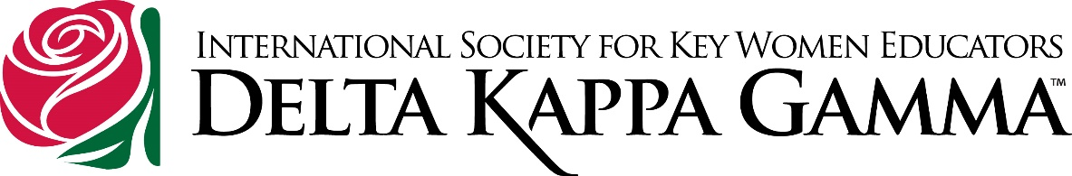
Congratulations, Ann McCain!
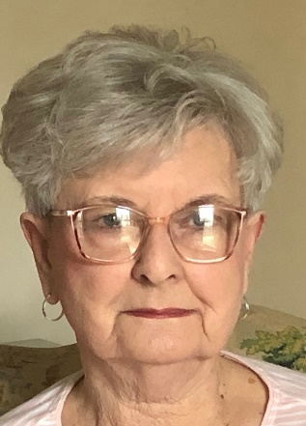

2023 NC DKG Golden Key Awardee Kappa Chapter, Region VIII
There are Angels in DKG and Ann McCain is one of them. Ann has solicited funds for the Cerebral Palsy Society for over 20 years, involving members and friends in her fundraising efforts. Inspired by a former Kappa President who had a son with cerebral palsy, Ann became involved with the local council of Easter Seals UCP (United Cerebral Palsy) and eventually the State Board. For 20 years, she served on the State Board of Directors and on the local council even longer. She looked to her Kappa Chapter for support, using a letter writing campaign to solicit donations and invite her sisters to participate in the actual walk —A Stroll in the Park. She was a top fundraiser, and to this day, the son of the former Kappa President who has cerebral palsy sits with her in church on Sundays. The Public Relations person for Easter Seals who became a teacher is now a Kappa member recruited by Ann. Ann is a leader who tackles situations head-on with dedication. She exemplifies an Educator with great Heart for her work and for all children.

